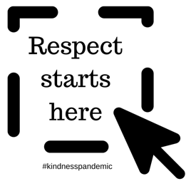

INSERT NAME OF POLITICAN HERE

INSERT DATE HERE

Dear [Insert name of the Politician here]

[tell them why you are writing to them – is this your local member etc]

[tell them why respectful conduct in Parliament matters to you eg: do you think respectful behaviour in parliament will: teach our children about respect? End conflict? Reduce family violence? Spread hope? Build faith in our politicians capacity to lead? End wars? Get the job done faster and more efficiently? Promote inclusion and greater humanity?]

This week the Kindness Pandemic launched a campaign called #RespectStartsHere. The campaign reaches out to political leaders around the world – to ask them to commit to respectful behaviour for the week until World Kindness Day on 13th November.

I am sending this letter to ask you to commit to the campaign. I am asking you to share your commitment on social media to help raise awareness of the importance of respect – and to bring us hope.

You will find downloadable posters and social media banners on the #RespectStartsHere webpage (thekindnesspandemic.org/respectstartshere). If you would like to make a 1 min video on your commitment to respect, please post it to the Kindness Pandemic Facebook group and it will be shared with the 560,000 members at: https://www.facebook.com/groups/515507852491119

Yours sincerely

[Insert your name and contact details here]

