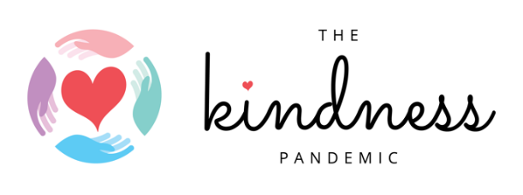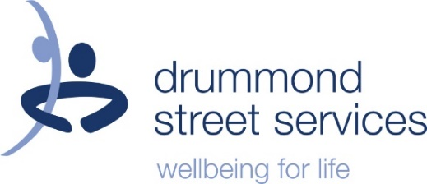

***MEDIA RELEASE***

Family Kindness Campaign launched to support families during COVID19

The impacts of COVID19 on families are significant. Family members have lost employment, many are juggling working from home and parenting and most children are learning remotely at home. With reports of increased levels of family violence there is a need to think about innovative ways to support families.

The Kindness Pandemic is partnering with drummond street services, a not for profit community services organisation supporting families in Victoria. The partnership focuses on four campaigns to engage:
- New Mums campaign raises awareness of the need to support new mums who have reduced ante and post-natal support
- Grateful Families campaign is focused around gratitude, particularly for children, that invites family members to develop a daily practice of finding one thing about a sibling or other family member that they are grateful for
- Families that Bend campaign invites families to share their stories and strategies for adapting to the change they are experiencing
- The Village Purse campaign gives community members a brief overview of how to support friends and families experiencing family violence and/or mental health issues

The Campaigns will be shared through the Kindness Pandemic Facebook group which grew to over 500,000 members within two weeks of being established. The group spreads acts of kindness to people who are struggling with the consequences of COVID19.

Kindness Pandemic Co-coordinator Merrin Wake says;

“I have seen the best of people in this time. Kindness is more than just a word or an act, it has the ability to change how we are in the world. The acts of kindness we have seen has made people feel heard, seen, supported and feel loved. Kindness is important, everyday.”

drummond street services CEO Karen Field said:

“Whilst clearly the impact of this pandemic is impacting on all, it has also served to magnify existing inequalities and is having disproportionate impacts on some in our community. It is often these voices that either don’t get a platform or missed within government and community discussions. Often vulnerable and marginalised communities who need the most amount of support often go unheard & unnoticed, we hope these campaigns can help support those in need, including those experiencing family and intimate partner violence as well as helping provide tips and strategies to cope in times of crisis”

For any media enquiries or to arrange an interview please contact:

- Merrin Wake, The Kindness Pandemic at info@thekindnesspandemic.org or 0422208776
- Phoebe Wallish, drummond street services on 0411 484 879 or 03-9663 6733 (sw) or phoebe.wallish@ds.org.au

For more information see The Kindness Pandemic website: www.thekindnesspandemic.org

