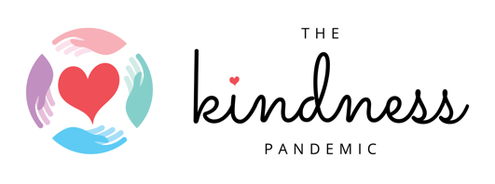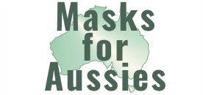

13/7/2020: Scientist, sewing machines and selfies
A new campaign to promote facemasks

Today the Kindness Pandemic joins forces with Masks for Aussies to launch a novel campaign promoting the use of facemasks in Australia. The Campaign promotes mask use through:

- Sewing machines: a national network of mask makers coordinated by Masks for Aussies that includes a Mapotic map enabling people to see where mask makers are in their local community
- Science: providing evidence based information on why a mask matters, how and when to wear one and how to clean one. The evidence has been collated by Masks for Aussies
- Selfies: community members are invited to share a selfie wearing a mask, use the hashtag #MaskKindness and share a few words about why they are wearing a mask. The call for selfies will go out through the Kindness Pandemic’s 560,000+ members and aims to normalise mask wearing

The first Campaign patron is Fiona Patten MP. Founder and Director of the Kindness Pandemic Dr Catherine Barrett said of the campaign

This campaign is focused on creating cultural change – to help people understand mask wearing as a new COVID normal. The partnership with Masks for Aussies will help to ensure masks are affordable. The opportunity then exists to utilise social media to help build community confidence wearing a mask – most people have never considered a mask. We particularly want to see masks being worn in supermarkets and on public transport

Masks for Aussies said
We are so thrilled to be able to work together with the Kindness Pandemic collaborating towards a goal of making sure every Australian has access to face masks, no matter their circumstances. This project will allow thousands of people to offer help their fellow community members by making reusable masks. People who need masks will be easily able to find makers prepared to help! If ever we needed an epidemic of kindness, it’s right now and support of the community supply mapping project will make a huge difference.

Website: thekindnesspandemic.org/maskkindness

Contact
- Dr Catherine Barrett, The Kindness Pandemic: info@thekindnesspandemic.org or 0429582237
- Beth Crothers, Masks for Aussies: admin@masksforaussies.com or 041901321

